Mihir Srivastava

[mihir.12107590@lpu.in](mailto:mihir.12107590@lpu.in)

[mihir.srivastava001@gmail.com](mailto:mihir.srivastava001@gmail.com)

**MINI PROJECT: PERFORMING EDA ON A DATASET**

**Q1.**

This dataset is detailed analysis about ideal customers.

By going through the given dataset, following things can be concluded:

* It helps in understanding customers in better way,
* It also helps in easily modification of products according to needs and behaviours,
* It can also help in upgradation of business of the company.

**Q2.**

Income column has highest number of missing values i.e., 24.

Percentage of missing value = 1.071429%

**Q3.**

No. of columns not having more than 1 value are 2, i.e.,

* Z_CostContact
* Z_Revenue

**Q4.**

Statistical data of numerical values in dataset are as follows:

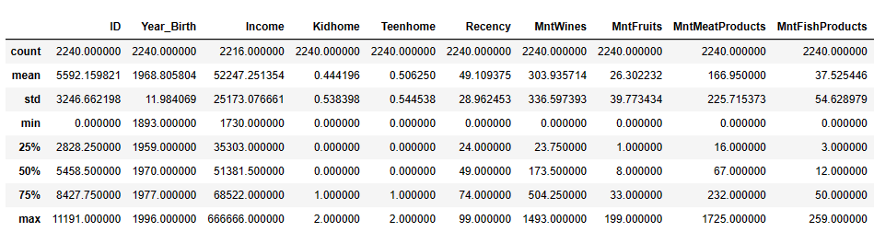

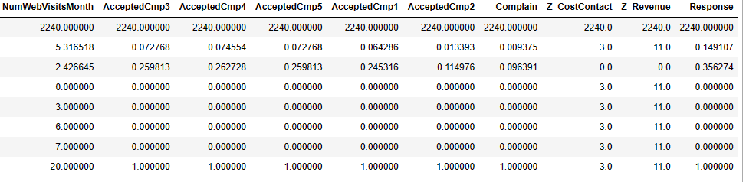

Unique columns in given data set are as follows:

* ID
* Income
* ID_NumWebVisitsMonth
* ID_Year_Birth
* ID_Income

**Q5.**

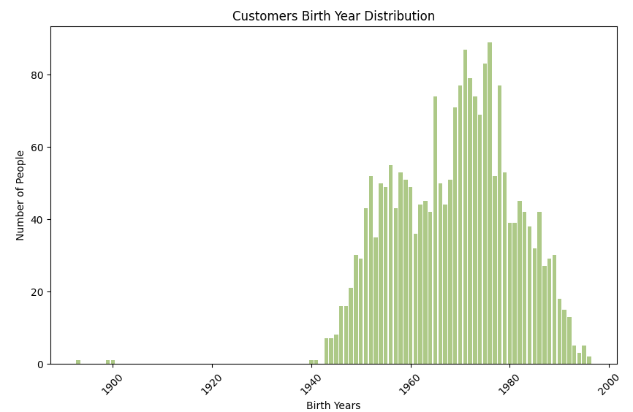

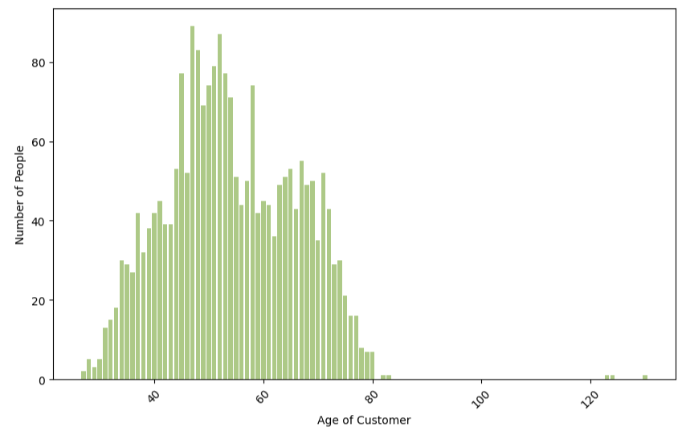

**Q6.**

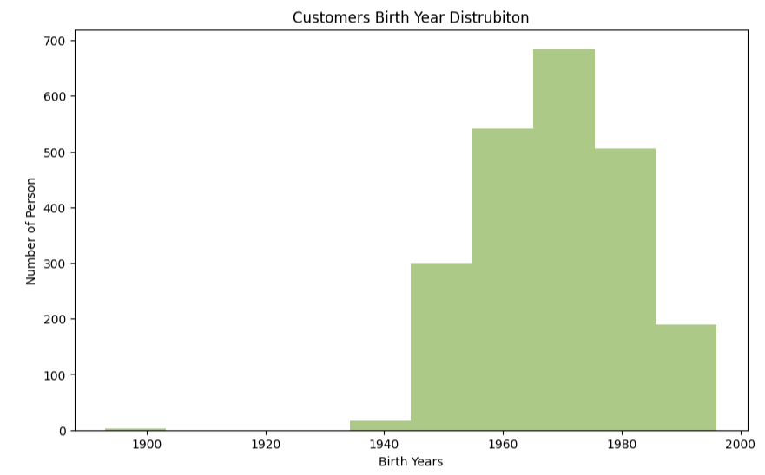

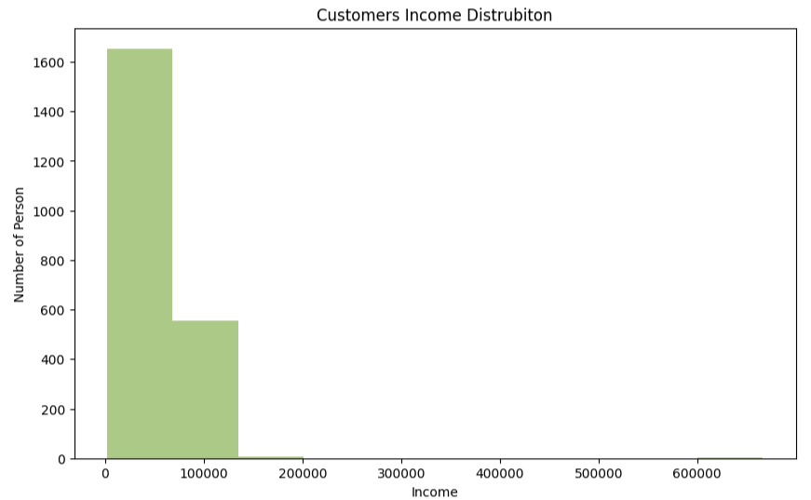

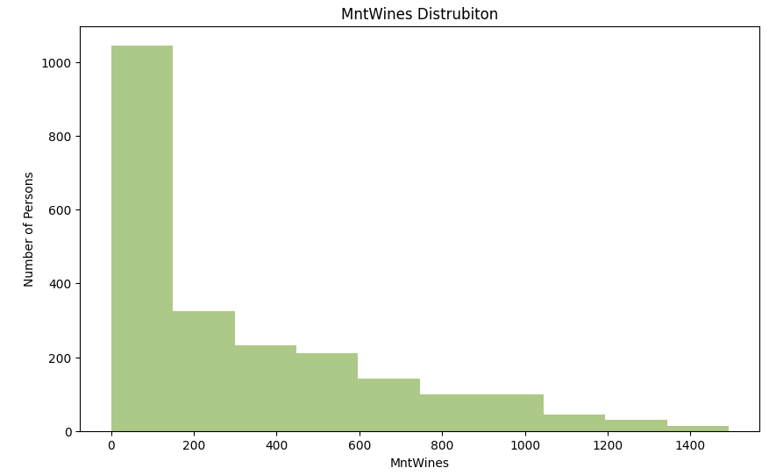

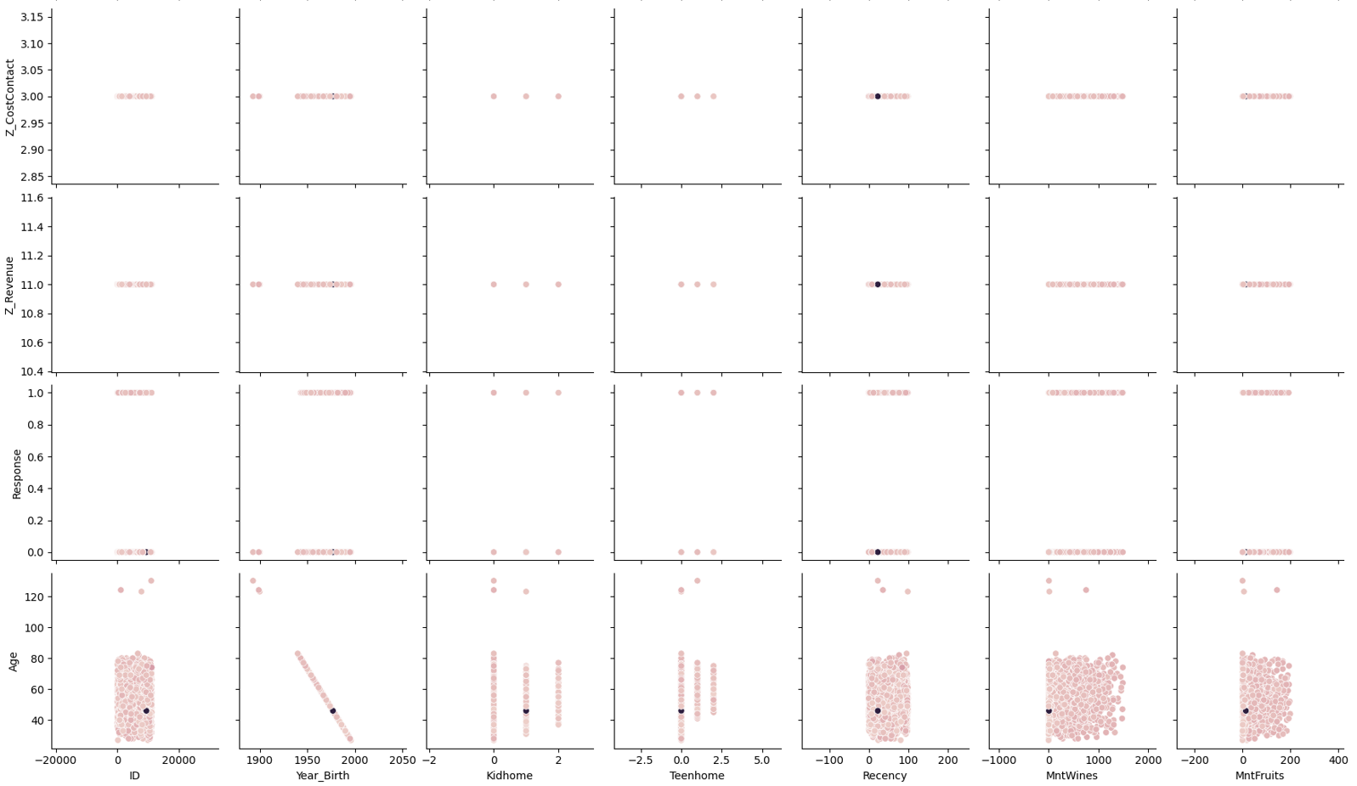**Q7.**

**Q8.**

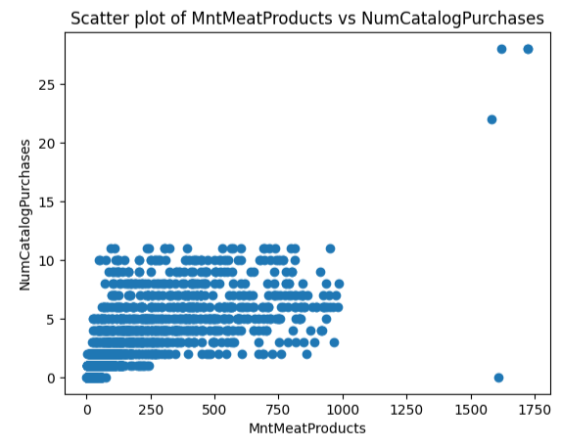

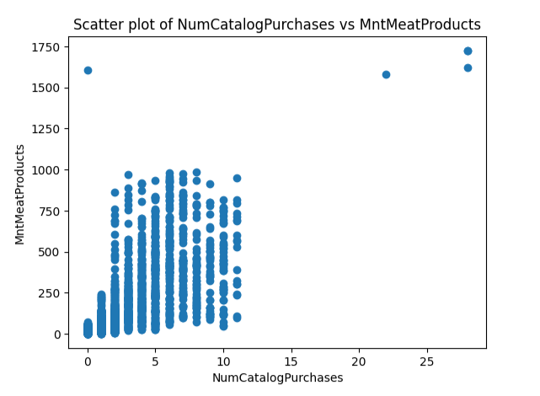

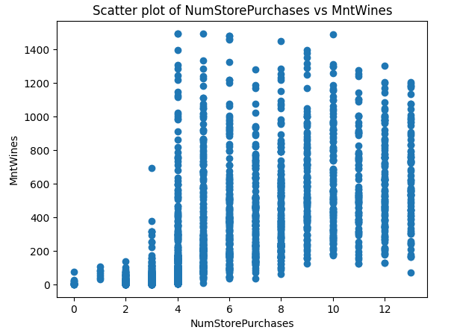

**Q9.**

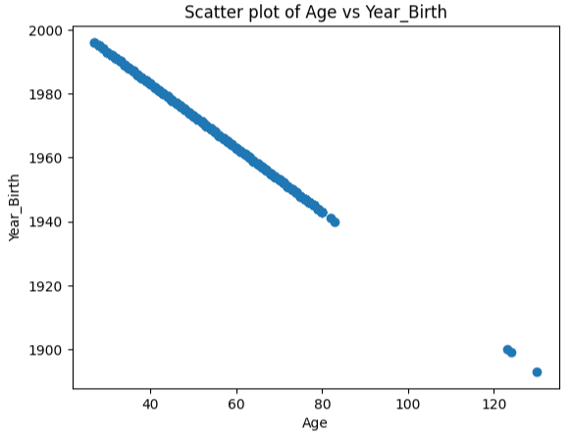

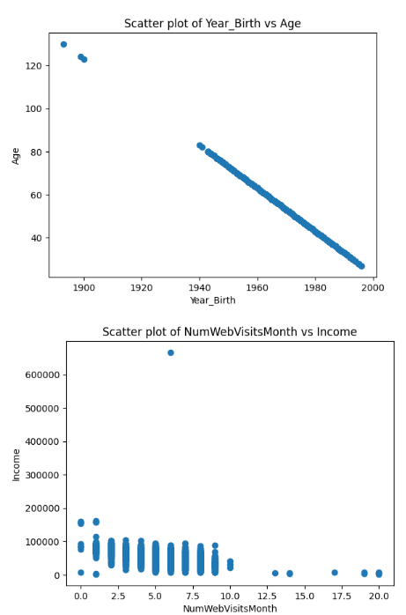

**Q10.**

* Knowing about the datatypes of the given dataset

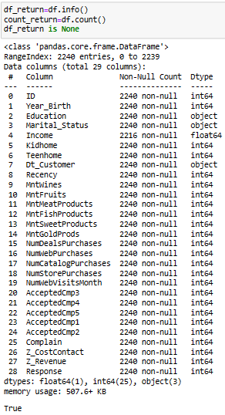

* 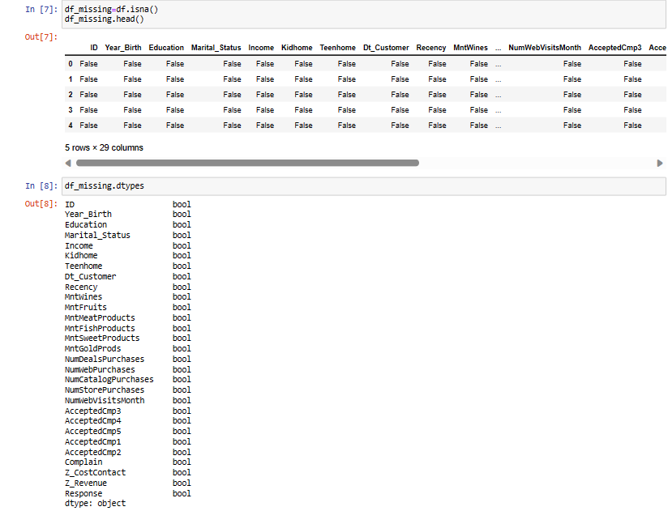Converting data into Boolean form for checking missing values